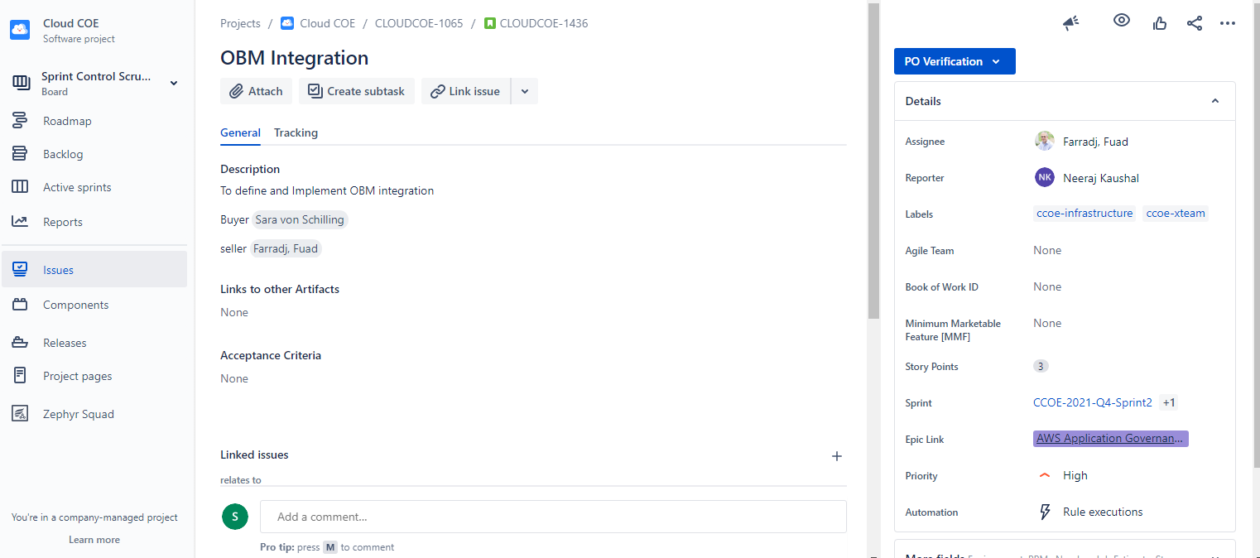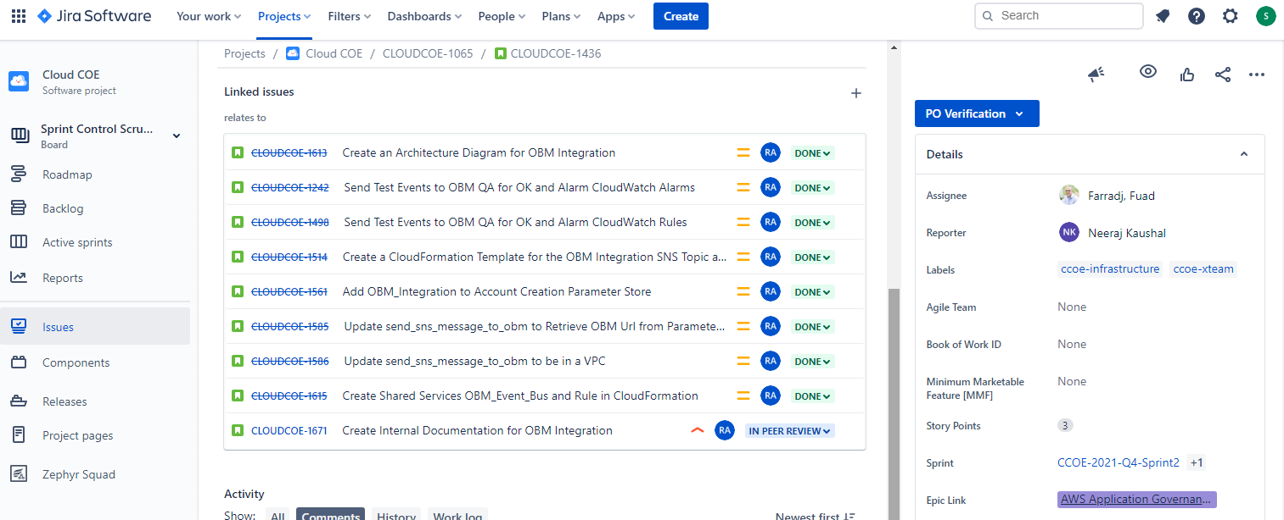

Send Test Events to OBM QA for OK and Alarm CloudWatch Alarms

I would like to send test events to OBM QA for OK and Alarm CloudWatch Alarms  
so that ENOC can create filters on their end to retrieve SNS Messages from AWS

**Buyer:** Larry Guest

**Tasks:**

1. Create a test CloudWatch Alarm for EC2 to send an OK to OBM QA
2. Create a test CloudWatch Alarm for EC2 to send an Alarm to OBM QA
3. Create a test CloudWatch Alarm for RDS to send an OK to OBM QA
4. Create a test CloudWatch Alarm for RDS to send an Alarm to OBM QA
5. Verify ENOC received both alerts

# Send Test Events to OBM QA for OK and Alarm CloudWatch Rules

I would like to send test events to OBM QA for OK and Alarm CloudWatch Rules  
so that ENOC can create filters on their end to retrieve SNS Messages from AWS

**Buyer:** Larry Guest

**Tasks:**

1. Create a test CloudWatch Rule for EC2 to send that an instance is running to OBM QA
2. Create a test CloudWatch Rule for EC2 to send an instance is stopped to OBM QA
3. Verify ENOC received both alerts

# Create a CloudFormation Template for the OBM Integration SNS Topic and Lambda

I would like to create a CloudFormation Template for the OBM Integration SNS Topic and Lambda  
so that we can deploy the solution as infrastructure as code

**Buyer:** Blair, Nina

**Tasks:**

1. Add the SNS topic to the CloudFormation stack
2. Add the Lambda to the CloudFormation stack
3. Deploy to SharedServices Dev
4. Deploy to SharedServices Prod

# Add OBM_Integration to Account Creation Parameter Store

I would like to add OBM_Integration to Account Creation Parameter Store  
so that new accounts get added to the OBM_Integration SNS Topic

**Buyer:** Blair, Nina

**Tasks:**

1. Add OBM_Integration to Account Creation Parameter Store in Shared Services Dev
2. Add OBM_Integration to Account Creation Parameter Store in Shared Services Prod

# Update send_sns_message_to_obm to Retrieve OBM Url from Parameter Store

I would like to update send_sns_message_to_obm to Retrieve OBM URL from Parameter Store  
so that we don't hardcode the URL into the Lambda

**Buyer:** Blair, Nina

**Tasks:**

1. Add a mapping in the CloudFormation template to determine which URL to use
2. Add the URL to Parameter Store
3. Update the Lambda to get the URL from Parameter Store

# Update send_sns_message_to_obm to be in a VPC

I would like to update send_sns_message_to_obm to be in a VPC  
so that we are SAF compliant

**Buyer:** Blair, Nina

**Tasks:**

1. Add parameters to get the VPC and Subnet IDs
2. Update the permissions of the Lambda to include the permissions to create the Lambda in the VPC
3. Update the Lambda to deploy into the VPC and subnets

# Create Shared Services OBM_Event_Bus and Rule in CloudFormation

I would like to create Shared Services OBM_Event_Bus and Rule in CloudFormation  
so that we can deploy from IaC

**Buyer:** Blair, Nina

**Tasks:**

1. Create a OBM_Event_Bus in CloudFormation
2. Create the EventBridge Rule in CloudFormation

Comments by Fuad

Met with Siraj on Friday to discuss the effort for completing this initiative by adding partner accounts with transit/network connectivity events.

Need a deeper dive to define process and begin work with a single partner account and replicate the pattern for all other production workload accounts. Also need to work with POs to communicate plan/concept with partners.